

Machine Learning Techniques

SID: 2441156

December 2026

MSc Embedded Computing and Machine Learning
IoT and Machine Learning at the Edge on Arm

Table of Contents
List of figures 4
List of Tables 5
List of Listings 6
Introduction 7
1 System Design and Architecture 7
1.1 Architecture overview 7
1.2 Design decisions 9
1.3 System components 9
1.3.1 Hardware 9
1.3.2 Software 9
1.3.3 Cloud 10
2 Implementation 10
2.1 Dataset and Preprocessing 10
2.2 Baseline model 11
2.3 Optimisation 14
2.4 Deployment and Evaluation on Target 15
2.5 Cloud integration and local PC terminal 16
3 Critical Evaluation 17
3.1 Accuracy vs Efficiency 17
3.2 Performance Analysis 17
3.3 Strengths 18
3.4 Weaknesses 18
3.5 Challenges 18
3.6 Future improvements 19
3.6.1 CNN Model 19
3.6.2 Performance 19
4 Conclusion 19
References 21
Appendices 24
Appendix A 24
Appendix B 25
Appendix C 26
Appendix D 27
Appendix E 28
Appendix F 29
Appendix G 30
Appendix H 31

List of figures
Figure 1: System architecture. 8
Figure 2: Model training accuracy and loss. 12
Figure 3: Confusion matrix. 13

List of Tables
Table 1: Class names and image distribution 10
Table 2: Classification report 13
Table 3: Evaluation for on target board 16

List of Listings
Listing 1: Functions used to split the dataset into train, validate and test groups. 10
Listing 2: Convolutional neural network model definition. 11
Listing 3: Dynamic quantization 14
Listing 4: Full integer quantization 14
Listing 5: Energy estimation in firmware 17

Introduction
The ability to recognise and classify healthy and diseased plants by analysing their leaves appearance helps farmers around the world to manage and prevent further diseases spread and potentially save great amounts of crops. Traditionally, such task is carried out by human workers requiring many hours spent in the fields identifying the leaves of each individual plant.
With an advance in technology this task however can be automated and accelerated. One of such technology is machine learning and artificial intelligence, which can be utilised for image recognition and classification of plants based on their health condition. It is indeed a challenging problem, but reliable and deployable ML models can prove to be valuable tool assisting farmers in early disease detection and can potentially help to improve the yields globally.
This project explores how various types of machine learning techniques can support such image-based plant disease detection and which models tend to be more accurate and efficient in this task.

Data Analysis and Visualisation
PlantVillage dataset (Mohanty Sharada P., Salathé Marcel and Digital Epidemiology Lab) is a collection of 54,306 photographs of diseased and healthy plant leaves covering 14 species and 26 plant diseases.

Dataset analysis
Dataset analysis revealed that the dataset consists of 38 classes and the actual number of images is 54,305. Additionally, the bar chart Figure 1 produced with Matplotlib (John Hunter, Darren Dale, Eric Firing, Michael Droettboom and the Matplotlib development team) shows that the number of images per class is highly imbalanced: the smallest class representing healthy potatoes images contains only 152 images, while the largest class representing orange greening disease counts for 5,507 images, making it ~32 times larger. The imbalance occurs across all classes – both crop type and its condition.
Further investigation of images metadata revealed that all are of 256x256 pixels size and all but one RGBA PNG are RGB JPEG files. After inspection the unusual image appeared to show a diseased fruit rather than a leaf, hence the decision to exclude it from the target dataset was made.
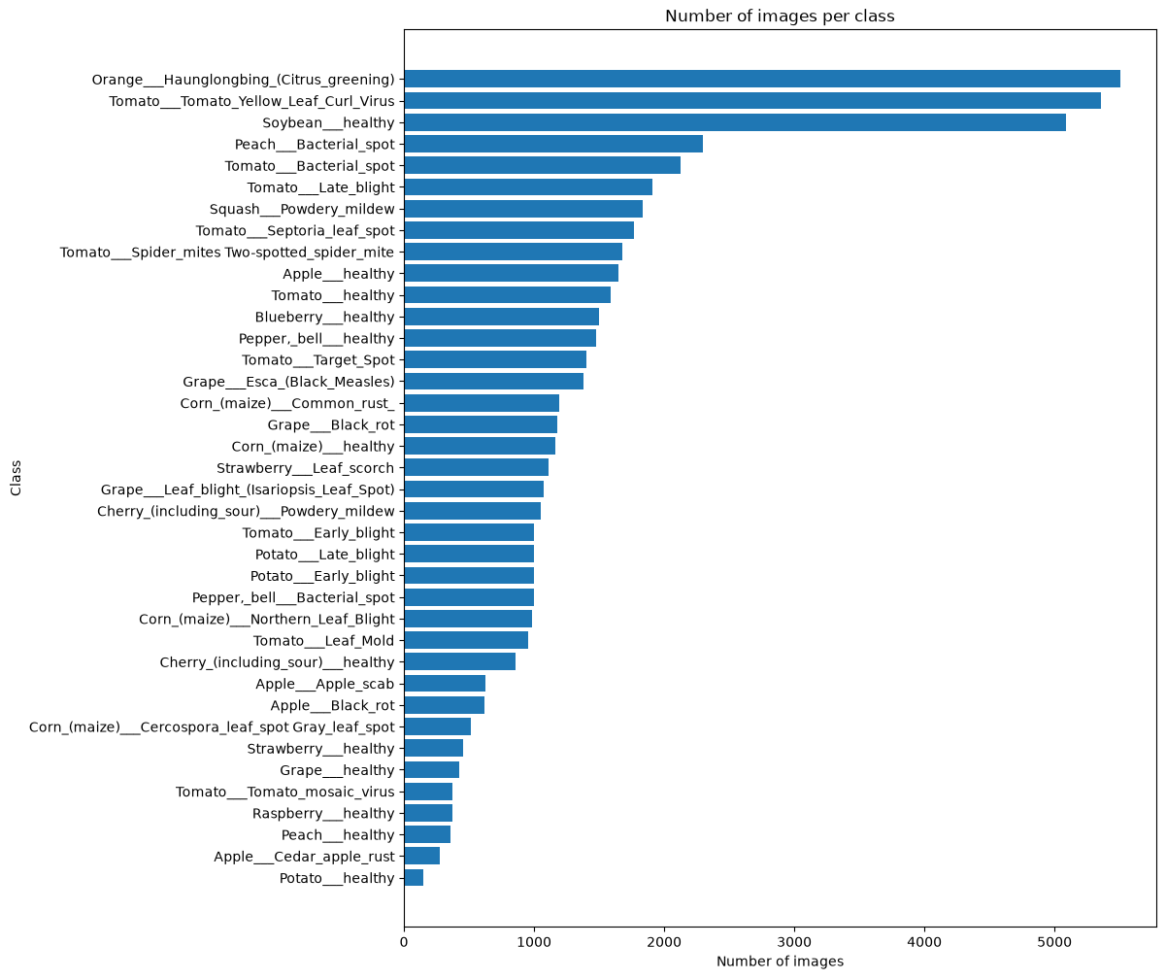
Figure 1: Class images distribution in dataset

Implementation

Dataset and Preprocessing
Amet stet eros ea velit rebum sed sit tempor. Clita dolor molestie ipsum aliquyam duo stet ut feugiat ipsum nam commodo adipiscing in lorem. Laoreet augue tempor. Nonumy nibh dolor kasd. Magna in sit lorem nonummy ut sed sadipscing ut dolor exerci voluptua sit imperdiet sadipscing clita te labore. At eu nostrud invidunt autem ut vero ut. No amet lorem sanctus sed gubergren elit dolor duo soluta ut ipsum amet sadipscing ea consetetur voluptua. Vulputate sit sadipscing praesent dolor mazim invidunt molestie hendrerit. Lorem justo et sea assum consetetur labore ipsum elitr et sit in. Zzril consetetur sea lorem ea. Nonumy vel sed qui at volutpat labore. Et dolor duis eirmod est ipsum dolore elitr eu tempor iriure feugait voluptua gubergren nulla invidunt.

Class | CBB | CBSD | CGM | CMD | Healthy
Count | 1087 | 2189 | 2386 | 13156 | 2577
Table 1: Class names and image distribution

train_df_split, temp_df_split = train_test_split(
train_df,
test_size=0.30,
stratify=train_df["label"],
random_state=SEED)

val_df_split, test_df_split = train_test_split(
temp_df_split,
test_size=0.50,
stratify=temp_df_split["label"],
random_state=SEED)

Listing 1: Functions used to split the dataset into train, validate and test groups.

Baseline model
Amet stet eros ea velit rebum sed sit tempor. Clita dolor molestie ipsum aliquyam duo stet ut feugiat ipsum nam commodo adipiscing in lorem. Laoreet augue tempor. Nonumy nibh dolor kasd. Magna in sit lorem nonummy ut sed sadipscing ut dolor exerci voluptua sit imperdiet sadipscing clita te labore. At eu nostrud invidunt autem ut vero ut. No amet lorem sanctus sed gubergren elit dolor duo soluta ut ipsum amet sadipscing ea consetetur voluptua. Vulputate sit sadipscing praesent dolor mazim invidunt molestie hendrerit. Lorem justo et sea assum consetetur labore ipsum elitr et sit in. Zzril consetetur sea lorem ea. Nonumy vel sed qui at volutpat labore. Et dolor duis eirmod est ipsum dolore elitr eu tempor iriure feugait voluptua gubergren nulla invidunt.
baseline_model = models.Sequential([
layers.Input(shape=(IMG_HEIGHT, IMG_WIDTH, 3)),
layers.Rescaling(1.0 / 255.0),

layers.Conv2D(16, (3, 3), activation="relu", padding="same"),
layers.MaxPooling2D((2, 2)),

layers.Conv2D(32, (3, 3), activation="relu", padding="same"),
layers.MaxPooling2D((2, 2)),

layers.Conv2D(64, (3, 3), activation="relu", padding="same"),
layers.MaxPooling2D((2, 2)),

layers.GlobalAveragePooling2D(),
layers.Dense(32, activation="relu"),
layers.Dropout(0.3),
layers.Dense(NUM_CLASSES, activation="softmax")
])

Listing 2: Convolutional neural network model definition.
Amet stet eros ea velit rebum sed sit tempor. Clita dolor molestie ipsum aliquyam duo stet ut feugiat ipsum nam commodo adipiscing in lorem. Laoreet augue tempor. Nonumy nibh dolor kasd. Magna in sit lorem nonummy ut sed sadipscing ut dolor exerci voluptua sit imperdiet sadipscing clita te labore. At eu nostrud invidunt autem ut vero ut. No amet lorem sanctus sed gubergren elit dolor duo soluta ut ipsum amet sadipscing ea consetetur voluptua. Vulputate sit sadipscing praesent dolor mazim invidunt molestie hendrerit. Lorem justo et sea assum consetetur labore ipsum elitr et sit in. Zzril consetetur sea lorem ea. Nonumy vel sed qui at volutpat labore. Et dolor duis eirmod est ipsum dolore elitr eu tempor iriure feugait voluptua gubergren nulla invidunt.
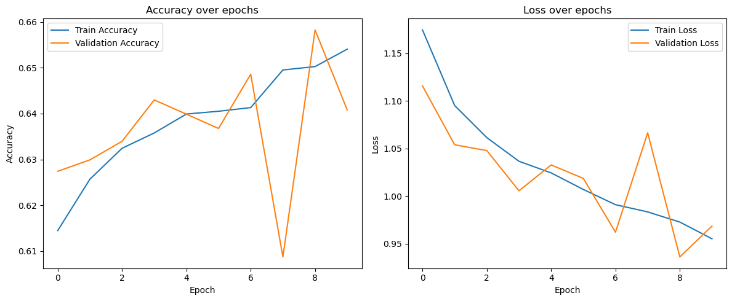
Figure 2: Model training accuracy and loss.

Amet stet eros ea velit rebum sed sit tempor. Clita dolor molestie ipsum aliquyam duo stet ut feugiat ipsum nam commodo adipiscing in lorem. Laoreet augue tempor. Nonumy nibh dolor kasd. Magna in sit lorem nonummy ut sed sadipscing ut dolor exerci voluptua sit imperdiet sadipscing clita te labore. At eu nostrud invidunt autem ut vero ut. No amet lorem sanctus sed gubergren elit dolor duo soluta ut ipsum amet sadipscing ea consetetur voluptua. Vulputate sit sadipscing praesent dolor mazim invidunt molestie hendrerit. Lorem justo et sea assum consetetur labore ipsum elitr et sit in. Zzril consetetur sea lorem ea. Nonumy vel sed qui at volutpat labore. Et dolor duis eirmod est ipsum dolore elitr eu tempor iriure feugait voluptua gubergren nulla invidunt.

 | Precision | Recall | F1-Score | Support
CBB | 0.23 | 0.02 | 0.03 | 163
CBSD | 0.36 | 0.49 | 0.42 | 329
CGM | 0.00 | 0.00 | 0.00 | 358
CMD | 0.75 | 0.92 | 0.83 | 1974
Healthy | 0.34 | 0.30 | 0.32 | 386
Accuracy |  |  | 0.65 | 3210
Macro avg. | 0.34 | 0.34 | 0.32 | 3210
Weighted avg. | 0.55 | 0.65 | 0.59 | 3210
Table 2: Classification report

Amet stet eros ea velit rebum sed sit tempor. Clita dolor molestie ipsum aliquyam duo stet ut feugiat ipsum nam commodo adipiscing in lorem. Laoreet augue tempor. Nonumy nibh dolor kasd. Magna in sit lorem nonummy ut sed sadipscing ut dolor exerci voluptua sit imperdiet sadipscing clita te labore. At eu nostrud invidunt autem ut vero ut. No amet lorem sanctus sed gubergren elit dolor duo soluta ut ipsum amet sadipscing ea consetetur voluptua. Vulputate sit sadipscing praesent dolor mazim invidunt molestie hendrerit. Lorem justo et sea assum consetetur labore ipsum elitr et sit in. Zzril consetetur sea lorem ea. Nonumy vel sed qui at volutpat labore. Et dolor duis eirmod est ipsum dolore elitr eu tempor iriure feugait voluptua gubergren nulla invidunt.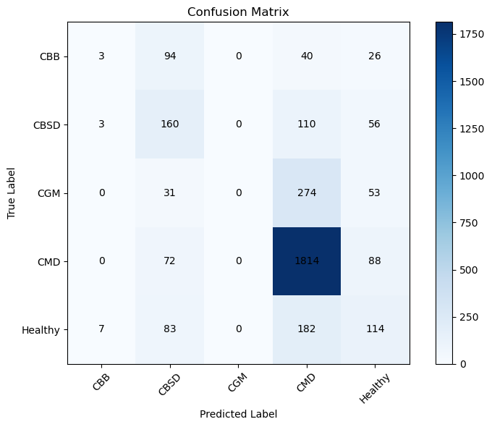
Figure 3: Confusion matrix.

Optimisation
Amet stet eros ea velit rebum sed sit tempor. Clita dolor molestie ipsum aliquyam duo stet ut feugiat ipsum nam commodo adipiscing in lorem. Laoreet augue tempor. Nonumy nibh dolor kasd. Magna in sit lorem nonummy ut sed sadipscing ut dolor exerci voluptua sit imperdiet sadipscing clita te labore. At eu nostrud invidunt autem ut vero ut. No amet lorem sanctus sed gubergren elit dolor duo soluta ut ipsum amet sadipscing ea consetetur voluptua. Vulputate sit sadipscing praesent dolor mazim invidunt molestie hendrerit. Lorem justo et sea assum consetetur labore ipsum elitr et sit in. Zzril consetetur sea lorem ea. Nonumy vel sed qui at volutpat labore. Et dolor duis eirmod est ipsum dolore elitr eu tempor iriure feugait voluptua gubergren nulla invidunt.

Deployment and Evaluation on Target
Amet stet eros ea velit rebum sed sit tempor. Clita dolor molestie ipsum aliquyam duo stet ut feugiat ipsum nam commodo adipiscing in lorem. Laoreet augue tempor. Nonumy nibh dolor kasd. Magna in sit lorem nonummy ut sed sadipscing ut dolor exerci voluptua sit imperdiet sadipscing clita te labore. At eu nostrud invidunt autem ut vero ut. No amet lorem sanctus sed gubergren elit dolor duo soluta ut ipsum amet sadipscing ea consetetur voluptua. Vulputate sit sadipscing praesent dolor mazim invidunt molestie hendrerit. Lorem justo et sea assum consetetur labore ipsum elitr et sit in. Zzril consetetur sea lorem ea. Nonumy vel sed qui at volutpat labore. Et dolor duis eirmod est ipsum dolore elitr eu tempor iriure feugait voluptua gubergren nulla invidunt.

Metric | Plain TFLite | UINT8 TFLite | Improvement
Input size | 32x32x4(float32) | 32x32x4(uint8) | 4 x smaller
MACC | 2,862,496 | 2,839,946 | ~ similar
Accuracy | 0.6514 | 0.6532 | ~ similar
Flash required | 116.84 KiB | 62.84 KiB | ↓ ~46%
RAM required | 28.67 KiB | 16.47 KiB | ↓ ~43%
Cycles/MACC | 9.52 | 2.45 | ↑ ~74%
Target inference time | ~340 ms | ~87 ms | ~4 x faster
Est. energy / inference | ~11.22 mJ | ~2,9 mJ | ~4 x lower
Deployable on STM32L475 | Yes | Yes | both fit
Table 3: Evaluation for on target board

Cloud integration and local PC terminal
Amet stet eros ea velit rebum sed sit tempor. Clita dolor molestie ipsum aliquyam duo stet ut feugiat ipsum nam commodo adipiscing in lorem. Laoreet augue tempor. Nonumy nibh dolor kasd. Magna in sit lorem nonummy ut sed sadipscing ut dolor exerci voluptua sit imperdiet sadipscing clita te labore. At eu nostrud invidunt autem ut vero ut. No amet lorem sanctus sed gubergren elit dolor duo soluta ut ipsum amet sadipscing ea consetetur voluptua. Vulputate sit sadipscing praesent dolor mazim invidunt molestie hendrerit. Lorem justo et sea assum consetetur labore ipsum elitr et sit in. Zzril consetetur sea lorem ea. Nonumy vel sed qui at volutpat labore. Et dolor duis eirmod est ipsum dolore elitr eu tempor iriure feugait voluptua gubergren nulla invidunt.

Critical Evaluation
Amet stet eros ea velit rebum sed sit tempor. Clita dolor molestie ipsum aliquyam duo stet ut feugiat ipsum nam commodo adipiscing in lorem. Laoreet augue tempor. Nonumy nibh dolor kasd. Magna in sit lorem nonummy ut sed sadipscing ut dolor exerci voluptua sit imperdiet sadipscing clita te labore. At eu nostrud invidunt autem ut vero ut. No amet lorem sanctus sed gubergren elit dolor duo soluta ut ipsum amet sadipscing ea consetetur voluptua. Vulputate sit sadipscing praesent dolor mazim invidunt molestie hendrerit. Lorem justo et sea assum consetetur labore ipsum elitr et sit in. Zzril consetetur sea lorem ea. Nonumy vel sed qui at volutpat labore. Et dolor duis eirmod est ipsum dolore elitr eu tempor iriure feugait voluptua gubergren nulla invidunt.

Conclusion
Amet stet eros ea velit rebum sed sit tempor. Clita dolor molestie ipsum aliquyam duo stet ut feugiat ipsum nam commodo adipiscing in lorem. Laoreet augue tempor. Nonumy nibh dolor kasd. Magna in sit lorem nonummy ut sed sadipscing ut dolor exerci voluptua sit imperdiet sadipscing clita te labore. At eu nostrud invidunt autem ut vero ut. No amet lorem sanctus sed gubergren elit dolor duo soluta ut ipsum amet sadipscing ea consetetur voluptua. Vulputate sit sadipscing praesent dolor mazim invidunt molestie hendrerit. Lorem justo et sea assum consetetur labore ipsum elitr et sit in. Zzril consetetur sea lorem ea. Nonumy vel sed qui at volutpat labore. Et dolor duis eirmod est ipsum dolore elitr eu tempor iriure feugait voluptua gubergren nulla invidunt.
Word count: 3000

References
John Hunter, Darren Dale, Eric Firing, Michael Droettboom and the Matplotlib development team, Matplotlib 3.11.2 documentation. [on-line] Available at: <https://matplotlib.org/stable/> [Accessed: 31.10.2026].
Mohanty Sharada P., Salathé Marcel and Digital Epidemiology Lab, E., PlantVillage-Dataset. [on-line] Available at: <https://github.com/spMohanty/PlantVillage-Dataset> [Accessed: 27.10.2026].

Appendices

Appendix A
Model sizes

Appendix B
Models’ accuracy

Appendix C
UINT8 Quantised Model Parameters

Appendix D
Plain TensorFlow Lite model STM32CubeMX Analyse Result.

Appendix E
UINT8 Quantised TensorFlow Lite model STM32CubeMX Analyse Result.

Appendix F
The full source code available at:

Appendix G
Running application – PC terminal output

Appendix H
Presentation and Demo Slides.

